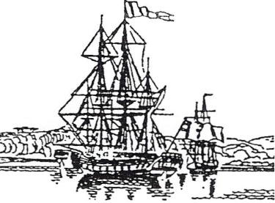**FELLOWSHIP OF FIRST FLEETERS**

1788 AD

*ABN 77003 223 425* **Patron***: Her Excellency, the Honourable Margaret Beazley AC KC, Governor of New South Wales***First Fleet House:** *105 Cathedral Street, Woolloomooloo NSW 2011*  
**Phone**: (02) 9360 3788

**Email:** [**membershipfff@optusnet.com.au Website**](mailto:membershipfff@optusnet.com.au%20%20%20%20%20%20Website)**:** [**www.fellowshipfirstfleeters.org.au**](http://www.fellowshipfirstfleeters.org.au)

to live on in the hearts and minds of descendants is never to die

**NAME BADGE ORDER**

**The Badge Price is $18.00 which includes postage**.

** BADGE SAMPLE**

The Badge is available for ORDINARY,

ASSOCIATE, PENSIONER, STUDENT,

JUNIOR, and FRIEND Members.

**\*Please complete the following with the Name that you wish to appear on the Badge**.

**ORDER 1.**

**\***NAME: …………………………………………………………………………………….

ANCESTOR: ……………………………………………………………………………….

ANCESTOR: ……………………………………………………………………………….

**ORDER 2**.

*NAME: ……………………………………………………………………………………

ANCESTOR: ………………………………………………………………………..........

ANCESTOR: ……………………………………………………………………………….

ANCESTOR: ………………………………………………………………………………

ANCESTOR: ……………………………………………………………………………….

**Please complete your POSTAL ADDRESS** -

Name ………………………………………….

Address …………………………………………………………………………………

Phone No. ……………………………. Mobile No……………………………………

Email Address……………………………………………………………………….

**Post the COMPLETED ORDER together with your payment to** -

**Fellowship of First Fleeters, ‘Badge Secretary’**

*First Fleet House:* 105 Cathedral Street, Woolloomooloo NSW 2011

***PAYMENT MAY BE MADE BY CHEQUE (made payable to Fellowship of First Fleeters) OR CREDIT CARD***

**CREDIT CARD PAYMENT USING – VISA/MASTERCARD:**

**NAME ON CARD:…………………………CARD NUMBER:…………………………….EXPIRY DATE:…………..**

**Signature:** __________________________________ **Date________________ Total Payment: ($ _____)**